Device Configurator Framework - Student Lab Instructions

Objectives

Part 1: Verify the Scripting Environment
Part 2: Build the Configurator Application
Part 3: Use the Configurator Application
Part 4: Conceptualizing Improvements

Estimated completion: 75 minutes

Background / Scenario

In this lab, students will build a menu-driven Python application that interacts with a Cisco CSR1000v device. The primary objective of this lab is to demonstrate simple code modularity. Not all possible features or functions are implemented. Instead, students are encouraged to think about ways to expand and improve upon the given application.

Important Note: Code in this document may be presented for visual clarity. Student’s code should follow proper indentation - refer to Python Style Guidelines (PEP8).

Part 1: Verify the Scripting Environment.

Step 1a.
Open the DEVASC VM console to verify the Python environment and install prerequisites if missing.

In the DEVASC VM console, open the Terminal and type:

python3 –version

Ensure Version 3 is present. Verify netmiko and requests packages are installed:

pip show netmiko
pip show requests

If they are missing, install them with pip install netmiko and pip install requests.

Step 1b.
Identify and record the CSR1000v IP address.

Open the console of the CSR1000v virtual machine. Type the command

show ip interface brief

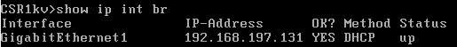

The figure above is an example only. Record the IP address shown for GigabitEthernet1. Close the CSR1000v console.

Part 2. Build the Configurator Application.

For reference, you will use Visual Studio Code to create the following files in the working directory:

capstone_main.py
capstone_dev_mgt.py
capstone_inv_mgt.py
get_current_device.py
current_device.json
device_list.json (optional)
/cisco_cmd
interfaces_rest.py
show_ip_int_br.py
show_ver_uptime.py (optional)

Step 2a.
Create the project working directories.

In the DEVASC VM terminal, type:

mkdir /home/devasc/labs/capstone-project
mkdir /home/devasc/labs/capstone-project/cisco_cmd

Step 2b.
Create the main executable, capstone_main.py.

In the DEVASC VM terminal, open Visual Studio Code and copy or type the following into a blank tab:

from capstone_inv_mgt import inv_main
from capstone_dev_mgt import dev_main

def main():
while True:

try:

print("*** MAIN MENU ***" + "\n" "________" + "\n")

print("1. Inventory Management" + "\n" + "2. Device Management" + "\n" + "9. Quit" + "\n" + "________\n")

user_input = input("Selection: ")
user_input = int(user_input)

if user_input == 1:
inv_main()
elif user_input == 2:
dev_main()
elif user_input == 9:
print("Goodbye.")
break
else:
print("Invalid number. Try again.")

except:
print("Error: Invalid Entry.")

if __name__ == "__main__":
main()

Click File, Save As. Navigate to the directory

/home/devasc/labs/capstone-project

Name the file capstone_main.py. Click Save. Do not close Visual Studio Code. Open a new tab for the next step.

Step 2c.
Create the capstone_dev_mgt.py subscript.

Using the same techniques described in Step 2b, create capstone_dev_mgt.py with the code below:

from get_current_device import get_current_device
from cisco_cmd.show_ip_int_br import show_ip_int_br
from cisco_cmd.show_ver_uptime import show_ver_uptime
from cisco_cmd.interfaces_rest import interfaces_rest

def dev_main():

while True:

try:

print("*** DEVICE MANAGEMENT MODE ***" + "\n" "________" + "\n")

var_router = get_current_device()

print("Current Device: "+ var_router["host"])

print("1. show ip int br" + "\n" + "2. show ver uptime" + "\n" + "3. interfaces-state (REST)" + "\n" + "9. Return to Main" + "\n" + "________\n")

user_input = input("Selection: ")
user_input = int(user_input)

if user_input == 1:
show_ip_int_br()
elif user_input == 2:
show_ver_uptime()
elif user_input == 3:
interfaces_rest()
elif user_input == 9:
print("Going back to Main.")
break
else:
print("Invalid entry! Try again.")

except:
print("Unexpected error in: dev_main")
break

Question 2c: What is the purpose of the line user_input = int(user_input)? What would happen without it?

Type your answer here:
Step 2d.
Create the capstone_inv_mgt.py subscript.

Using the same techniques described in Step 2b, create capstone_inv_mgt.py with the code below:

def inv_main():
while True:

try:
print("*** INVENTORY MANAGEMENT MODE ***" + "\n" "________" + "\n")
input("Nothing to see here. Hit enter to return to the Main Menu.")
break

except:
print("Unexpected error in: inv_main")

Step 2e.
Create the get_current_device.py subscript.

Using the same techniques described in Step 2b, create get_current_device.py with the code below:

def get_current_device():
import json

with open('current_device.json', 'r', encoding='utf-8') as f:
current_device = json.load(f)

return(current_device)

Step 2f.
Create the current_device.json file. This single dictionary entry contains the IP address of the CSR1000v router.

Using the same techniques described in Step 2b, create current_device.json with the snippet below, using the IP address of your router recorded in Step 1b.

{
"device_type": "cisco_ios",
"host": "192.168.197.131",
"port": "22"
}

Question 2f: What other device information might be useful to contain in this file?

Type your answer here:

Step 2g.
Create the cisco_cmd\show_ip_int_br.py script.

Using the same techniques described in Step 2b, create cisco_cmd\show_ip_int_br.py with the code below:

from netmiko import ConnectHandler
from get_current_device import get_current_device
import getpass

var_router = get_current_device()

def show_ip_int_br():

while True:

try:
usernm = input("Username: ")
passwd = getpass.getpass("Password: ")
var_router["password"] = passwd
var_router["username"] = usernm

with ConnectHandler(**var_router) as conn:

print("Connecting to: " + var_router["host"])

net_connect = ConnectHandler(**var_router)
output = conn.send_command('show ip interface brief')
print(output + ".\n")
net_connect.disconnect()
break

except:
print("Unexpected Error in: show_ip_int_br")
break

Be sure to save the file in the cisco_cmd directory.

Step 2h (optional).
Refer to Step 2g. Create the cisco_cmd\show_ver_uptime_br.py script.

Copy and paste but modify the 22nd line from Step 2g:

output = conn.send_command('show ip interface brief')

to:

output = conn.send_command('show ver | inc uptime')

Keep everything else the same and save the file as cisco_cmd\show_ver_uptime_br.py.

Step 2i.
Create the cisco_cmd\interfaces_rest.py script.

Using the same techniques described in Step 2b, create cisco_cmd\show_interfaces_rest.py with the code below:

import requests
import pprint
import getpass
from get_current_device import get_current_device

var_router = get_current_device()

def interfaces_rest():

while True:

try:
usernm = input("Username: ")
passwd = getpass.getpass("Password: ")

HOST = var_router["host"]
URL_BASE = f"https://{HOST}/restconf/data"
AUTH = (usernm, passwd)
HEADERS = {
'Content-Type': 'application/yang-data+json',
'Accept': 'application/yang-data+json'
}

url = f"{URL_BASE}/ietf-interfaces:interfaces-state/"
response = requests.get(url, auth=AUTH, headers=HEADERS, verify=False)
pprint.pprint(response.json())
break

except:
print("Unexpected Error in: interfaces_rest")
break

Question 2i: What is the purpose of verify=False? Try changing it to verify=True and explain the result (wait until completing Step 3d):

Type your answer here:

Step 2j.
Verify all files are present as noted at the beginning of Part 2.

In the DEVASC VM terminal, type ls -la. Your output should be similar to the following (absolute paths may differ):

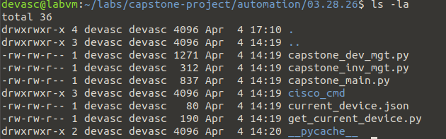
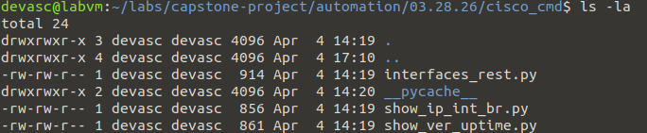

Part 3. Use the Configurator Application.

Step 3a.
Open the DEVASC VM terminal and launch the application:

python3 capstone_main.py

You should be presented with the Main Menu, indicating successful code execution:

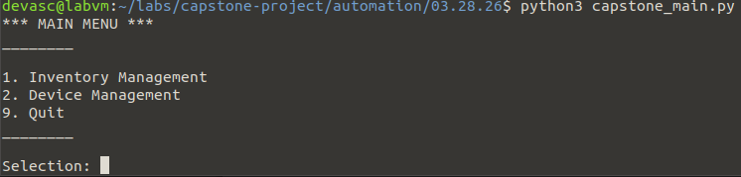

Insert your Main Menu screenshot here:

Step 3b.
Open Device Management mode by selecting Option #2.

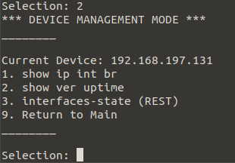

The output Current Device: 192.168.197.131 indicates that the get_current_device() function was able to open and read from the current_device.json dictionary file.

Step 3c.
Execute Option #1. When prompted, enter the username of cisco and the password cisco123!

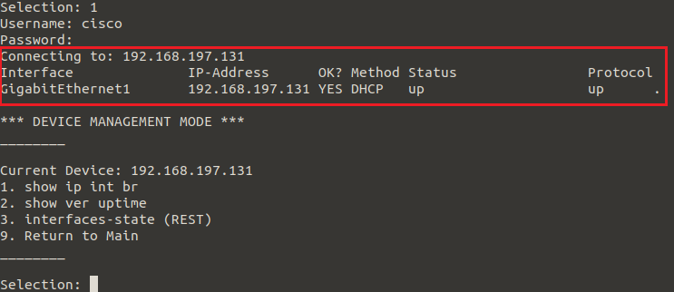

The output above shows a successful connection to the CSR1000v router using the Netmiko ConnectHandler (SSH) method.

Insert your Device Management Option #1 screenshot here:

Step 3d.
Execute Option #3. When prompted, enter the username of cisco and the password cisco123!

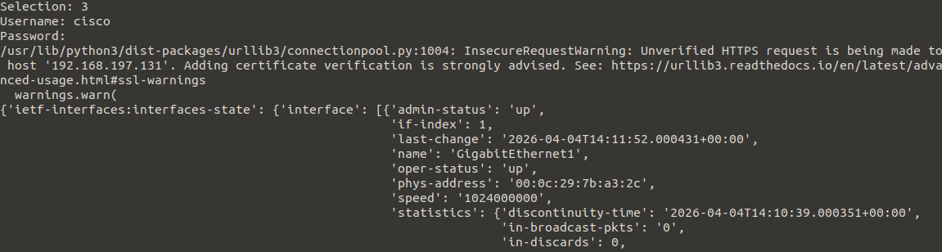

The output above shows a successful connection to the CSR1000v router using the requests.get() method.

Step 3e.
Exit the application by selection Option #9 twice.

Part 4. Conceptualizing Improvements.
In this lab, students have created a small framework to build upon. Lastly, we explore some opportunities for improvement.

Step 4a.
At this time, Inventory Management Mode is nonfunctional and states the following:

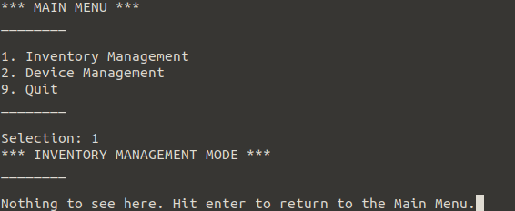

Consider the following Inventory Management sub-functions:

1. List Devices. Reads the device_list.json file and outputs all devices.
2. Set Current Device. Copies a selected device to current_device.json.
3. Add a Device. Appends a device to device_list.json.
4. Remove a Device. Removes a device from device_list.json.
5. Modify a Device.

What challenges might you encounter when implementing set_current_device() ?

Type your answer here:

Step 4b.
Device Management Mode functions currently retrieve information from the router. How might you implement a function that sets or writes device information, such as set_looopback0_ip() ? (this function would prompt the user for an IP address and subnet mask to create/set the router’s Loopback0 interface. Assume you’re using Netmiko/SSH).

Type your answer here:

Step 4c.
Examine the printed code that forms the Main Menu and Device Management Mode menus:

print("1. Inventory Management" + "\n" + "2. Device Management" + "\n" + "9. Quit" + "\n" + "________\n")

print("1. show ip int br" + "\n" + "2. show ver uptime" + "\n" + "3. interfaces-state (REST)" + "\n" + "9. Return to Main" + "\n" + "________\n")

Each time a menu option is added, the developer needs to append options to a single line of code. What opportunities exist to streamline and modularize the menu code?

Type your answer here:

Step 4d.
Suppose you want to implement a Device Management function called show_ip_route(). Given the existing structure of the project, what line of code would you need to add to the very top of capstone_dev_mgt.py?

Type your answer here:

End of lab.

